The Relevance of Cognitive Load Theory in the Workplace
  - Kim Gutierrez

Introduction
Cognitive load is a theoretical notion with an increasingly central role in educational literature and practice. The basic idea of cognitive load theory is that cognitive capacity in working memory is limited, so that if a learning task requires too much capacity, learning will be hampered (Chandler & Sweller, 1991). The recommended remedy is to design instructional systems that optimize the use of working memory capacity and avoid (Sweller, 1994). In this paper I will review cognitive load theory, its applicability to instructional design and its impact on my own work.

The Theory
To understand cognitive load theory, we need to understand how memory functions. The learner uses multiple senses to input and process information through attention and pattern recognition the input is processes in working or short term memory. Working memory concerns the amount of information the brain can hold and manipulate at once. Without an organizational method, the learner will not be able to process data. The organization method, or schema, used to manipulate the data would be stored in long term memory. Schema determines how new information is processed and stored. For learners, to “know” something it must be stored and retrieved from the long term memory (Paas & Sweller, 2004). Cognitive Load Theory assumes that learners possess “an effectively unlimited long-term memory holding cognitive schemas that vary in their degree of complexity and automation” (van Merriënboer & Ayres, 2005, p. 6).
Cognitive load refers to the total amount of mental effort being used in the working memory (Chandler & Sweller, 1991). The amount of information that the brain can process is limited. In order to effectively manipulate information the cognitive load must be less than the cognitive limit of the working memory (Paas & Sweller, 2004). Schema acquisition is the ultimate goal of cognitive load theory.

Impact on Instructional Design
According to Sweller, instructional design can be used to reduce cognitive load in learners by developing instruction with a cognitive load less than the cognitive limit. According to Sweller (2004), cognitive load theory provides a framework for designing complex instructional materials. Instructional strategies may differ depending on the project and stakeholder needs, but some instructional strategies that I have utilized that are consistent with Cognitive Load Theory are organizational strategies, sequencing, signaling, aligning and reducing redundancy (Mayer & Moreno, 2003). In my experience, these instructional strategies have had a consistently positive impact on training effectiveness when employed to reduce mental load of learners.
According to Paas & Sweller (2003), another factor that can impact the success of a particular instructional practice is the learner’s previous experience. As novice learners may not have the schemas to effectively process complex instruction in working memory, this could negatively impact training effectiveness. Learners with insufficient prior knowledge are a situation that I often experience in my own work. While the situation does impact learning it can be remedied with effective pertaining, a load-reducing method (Mayer & Moreno, 2003).

Analysis of My Work
After being exposed to Cognitive Load Theory at the beginning of the semester, I begin to analyze and improve some of my work to reduce unnecessary mental load for my learners. I have found this theory and its concepts most helpful when a learner is complaining that navigating blackboard, completing an assessment or any other task is overwhelming. Being aware of this theory has allowed me to more accurately translate a report of “being overwhelmed” into overload scenarios that allow for a more clearly defined solution. For example, when a learner reports that an infographic is overwhelming, instead of looking at this as a failure on the part of the user, I understand that the user’s working memory is overloaded with visual data. Depending on the scenario, some data may need to be off-loaded as audio, or pre-training may be needed (Mayer & Moreno, 2003). Understanding of the theory has provided me the knowledge and vocabulary to accurately describe the issues my learners are experience and provide a plausible solution to remedy the problem. While the majority of my experience is consistent with theory assumptions, there are occasions where I have built successful instructional materials that diverge from theory assumptions. I have provided examples of each to provide a better foundation for this reflection.

Theoretical Analysis Reflects Reality
One recent project whose design and outcomes reinforce theory was the redesign of The RS training Course in Blackboard. The RS Training Course was selected for redesign because it is one of the most heavily trafficked by operational staff, required the most learner support and users were consistently complaining of “feeling overwhelmed” when navigating the course. As part of the redesign, extraneous information was weeded from the course and the course was segmented into more manageable working components: RS Training, Mentor Training, and Specialty Product Training. This limited the extraneous cognitive load associated with navigation and aimed to achieve better coherence.
Before Redesign
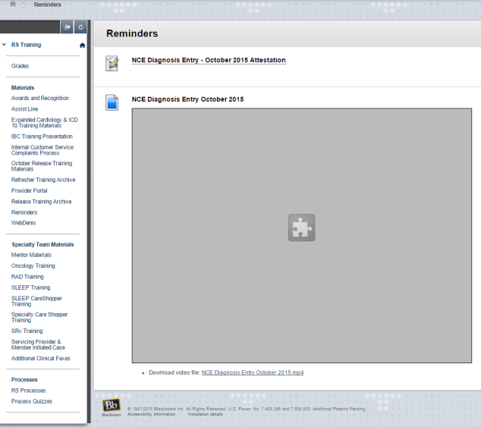
The homepage of the RS Training Course was redesigned to be more minimalist and aesthetically pleasing to the user. The renaming of content areas is a closer match between the system and the real world. These aspects of the redesign offload tasks associated with remembering specific locations of content and additional steps. The “Ask Questions” selection was implemented to limit the Split Attention Effect associated with going to outlook to email the education team for support needed in the course. The homepage also contains a table of contents that makes users aware of the materials located in each content area. This is a form of pretraining that also serves as error prevention associated with users going into the wrong course or area. The redesign improved the user experience in the course, as it limits some of the extraneous load associated with navigating and processing unneeded information.
After Redesign

Users surveyed reported 93% improvement rating of interface and an 82% improvement rate in ease of navigation. During the product evaluation of the redesign, navigation decreased between 18% and 33% depending on the task. Outside of official reports, I have observed a decrease in the technical support required by end users in the system.

A Clash of Theory and Reality

The above video is representation of a common instructional delivery mechanism utilized in the workplace. Upon analyzing this video with Cognitive Load Theory in mind, I identified issues with redundancy, split attention and modality effect. On this slide the trainer is talking about the topic in general terms, but a very specific table is on the screen. This causes a split attention issue as the user is concentrating on the chart when they should be listening to the trainer. This video also does not achieve modality effect as there are words are presented as text rather than verbally.
While this training, and many like it delivered in the workplace, violate some of the assumptions associated with Cognitive Load Theory, it is an effective training format as far as summative assessments and reaction surveys support. Users often comment on how they appreciate being able to see the instructor and content at the same time. Based on reaction surveys, this combination is rated 11% more positive than videos just showing instructor and 29% more positive than PowerPoints alone.

Conclusion
Overall, while I think that Cognitive Load Theory is an important influence in my instructional design, it is not the only factor to consider. In cases where Cognitive Load Theory aligns with the project objectives, this theory will play a primary role in redesign. However, I find that this theory is one of many and theories may conflict. For example, in the second example that I provided mental load could be reduced by removing the trainer from the video, as this would limit the information coming in through the visual channel. However, one of the key objectives of the assignment was to maximize learner engagement and motivation which is increased by the presence of a learning agent. My advice to anyone practicing instructional design would be to gain an understanding of the different theories, models and methodologies associated with field, but these theories should be used to inform practice, not dictate it.

Reference
Chandler, P., & Sweller, J. (1991). Cognitive load theory and the format of instruction. Cognition and instruction, 8(4), 293-332.
Mayer, R. E., & Moreno, R. (2003). Nine ways to reduce cognitive load in multimedia learning. Educational psychologist, 38(1), 43-52.
Paas, F., Renkl, A., & Sweller, J. (2003). Cognitive load theory and instructional design: Recent developments. Educational psychologist, 38(1), 1-4.
Paas, F., Renkl, A., & Sweller, J. (2004). Cognitive load theory: Instructional implications of the interaction between information structures and cognitive architecture. Instructional science, 32(1), 1-8.
Sweller, J. (1994). Cognitive load theory, learning difficulty, and instructional design. Learning and instruction, 4(4), 295-312.
van Merriënboer, J. J. G., & Ayres, P. (2005). Research on cognitive load theory and its design implications for e-learning. Educational Technology Research and Development, 53(3), 5-13.

