Kim Gutierrez

Final Prototype
A Review of the Blackboard LMS

Introduction
Nielsen’s Usability Heuristics and the frameworks associated with Cognitive Load Theory continue to be effective tools in identifying areas for potential improvement in the Blackboard Learn System utilized by AIM Specialty Health, Inc. This final round of redesign of the RS Training Course was directly impacted by the suggestions and feedback of end users. The final design should limit the extraneous cognitive load associated with utilization, decrease learner time spent in navigation and improve the overall learning experience.
Before Redesign
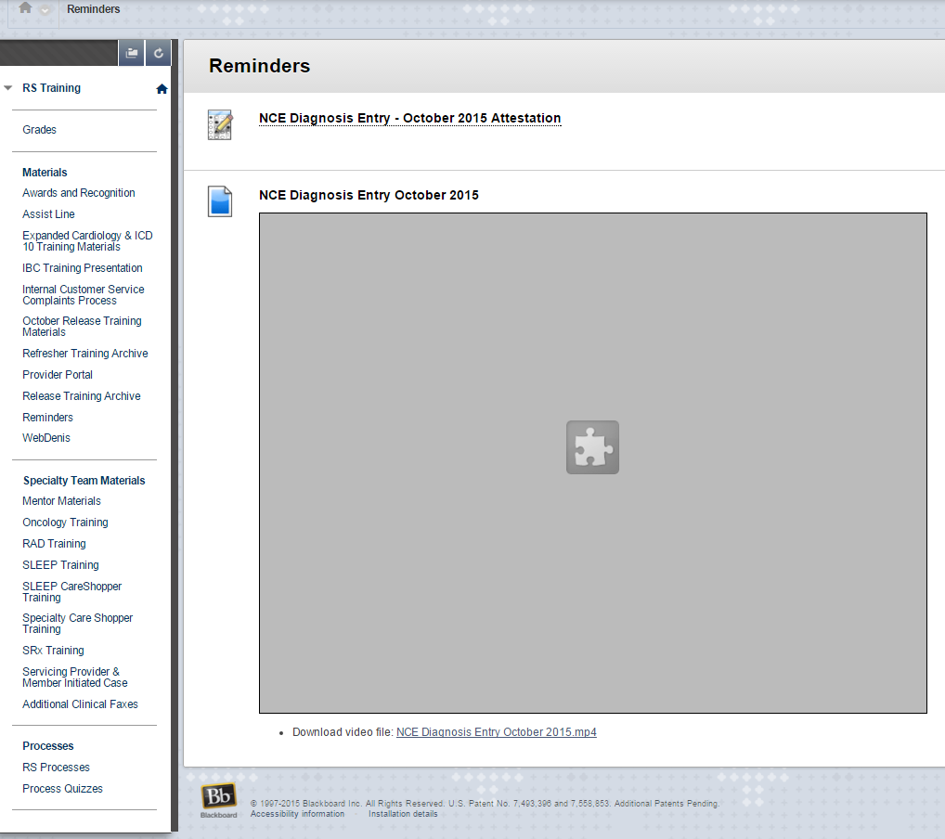
Areas from Improvement
After review of the Blackboard Learn system, and my observations and evaluations of user interactions within the newly designed courses, it was determined that the overall learner user experience in the system would be improved, if the naming convention employed in the course aligned with the workplace and additional help was embedded in the course.
- Systems match the Real World: Table of Contents terms should be easily understood by users.
- Help and Documentation: Additional documentation should be added at key points to guide users in completing tasks.
Limitations
Blackboard does not support a search function. While this functionality was added to the prototype, it will not be available for use in the near future. This is a system limitation that cannot be altered by my design. This was not a function reviewed by users during the previous scenario navigation.
Course Design Selection
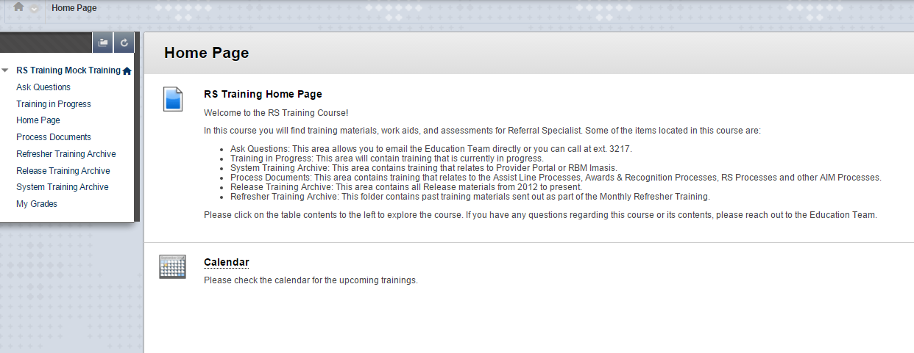

The RS Training Course was selected for redesign because it is one of the most heavily trafficked by AIM’s operational staff. It is also the course that requires the most user support based off of BMC Remedy Tickets. In the first round of redesign, the course was weeded of unnecessary information. The course was segmented into different working components: RS Training, Mentor Training, and Specialty Product Training. The purpose behind this decision was to create a minimalist design within each course and will limit the time spent navigating inside the individual courses and the extraneous load associated with the navigation.
RS Training Course Home Page

The homepage was redesigned for a minimalist and aesthetically pleasing user experience. The renaming of content areas is a closer match between the system and the Real World. These aspects of the redesign reduces extraneous cognitive load and prevent user error. The “Ask Questions” selection was implemented to limit the Split Attention Effect associated with going to Outlook to email the education team or to find an extension. The extension was added for users that require immediate support or users who are more comfortable with that route of support and also increases the help and documentation in the course. In the last round of redesign, a Table of Contents breakdown was added to the course that makes users aware of the materials located in each content area. This is a form of pre-training that also serves as error prevention associated with users going into the wrong course or area. The redesign will improve the user experience in the course, as it will limit some of the extraneous load associated with navigating and processing unneeded information.
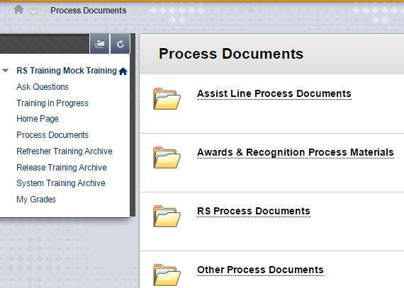
Following a minimalist design inside the course, folder titles utilized terms easily recognized by users. This design limits the excess cognitive load associated with navigating the course for needed material. The table of contents is also continually visible throughout the course. As this does increases the visual data that users will have to process which could overload some novice users, as users get used to the set up, it will increase their navigation efficiency.
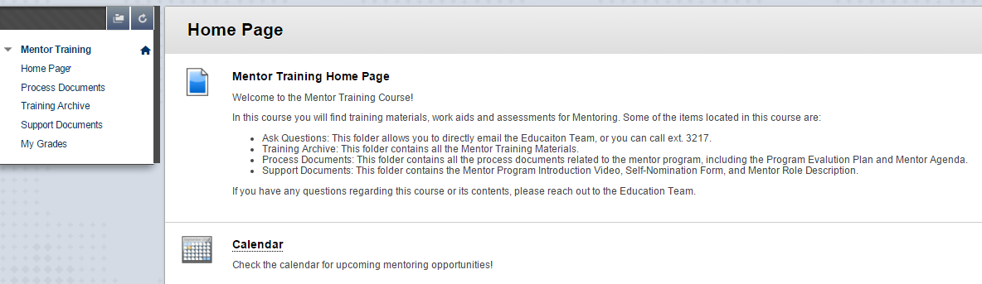
A consistent design from course to course will limit the extraneous load associated with adjusting to a new format. The table of contents will be present in every course, so that the user recognizes needed content, versus relying on memory to navigate. A training calendar has been added to the course to limit Split Attention Effect associated with checking the Training Calendar hosted on the AIM Intranet.
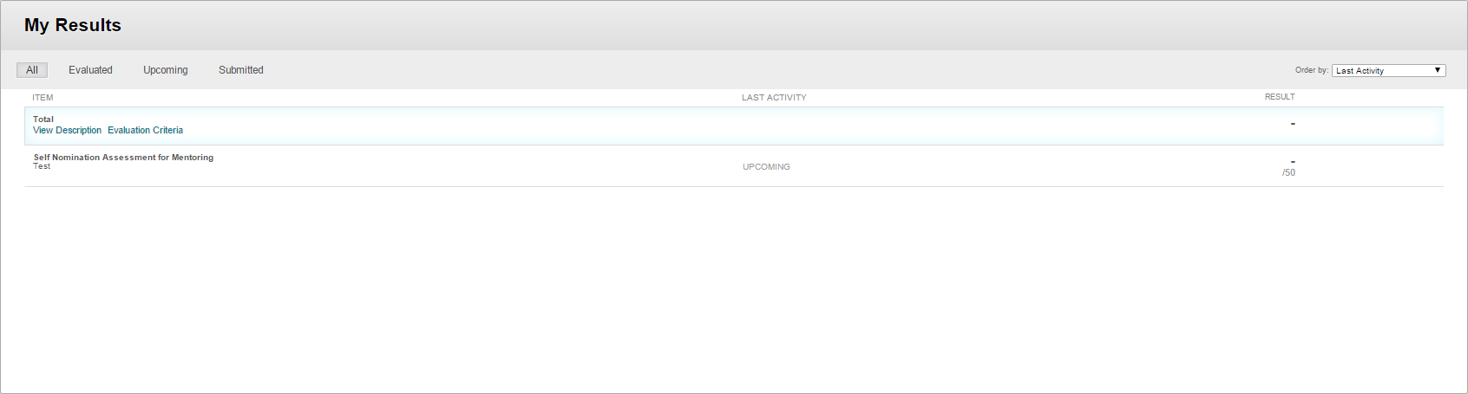
The gradebooks in the new courses will automatically open on the “All” tab and are limited to assessments delivered in the last 6 months with older assessments appearing at the bottom of this view. This will limit the number of assessments in the course and allow users to easily locate results. The minimal design will limit the extraneous cognitive load associated navigating this area.
Summary
Overall, the focus of this redesign was to limit the unnecessary mental load and improve the learning experience. By designing according to Nielsen’s 10 Heuristics, an interface was created that maximizes user’s efficiency in the system. Outside of the 10 heuristics, offloading strategies as described by Mayer & Moreno were utilized to further improve the design. Offloading strategies that were utilized during the redesign were weeding, segmenting, offloading and reducing redundancy (Mayer& Moreno, 2003). The combination of a Cognitive Load Theory framework and Nielsen’s 10 Heuristics allowed for the production of a design that allows users to spend less time navigating towards learning and more time learning.
Reference: Mayer, R. E. & Moreno, R. (2003). Nine ways to reduce cognitive load in multimedia learning. Educational Psychologist. 38, (1), 43-52.

