Kim Gutierrez

User Personas
A Review of the Blackboard LMS

User Personas
The user personas developed for this document are fictional character created to represent different users at AIM Specialty Health, Inc. The personas developed differ in the frequency of use, technology skill level and profile type in the Blackboard LMS.
Profile Type
Learner and Instructor profiles are available within the Blackboard system. Learner profiles make up the majority of users. This profile comprises 98% of helpdesk tickets as measure by the BMC Remedy System. An instructor persona was established as this profile has the biggest impact on learner experience, even though this profile represents less than 2% of total users.
Frequency of Use
A persona of a novice user was created as this represents the majority of AIM Specialty Health, Inc. It was important to include the persona of a super-user as they interact with the system differently.

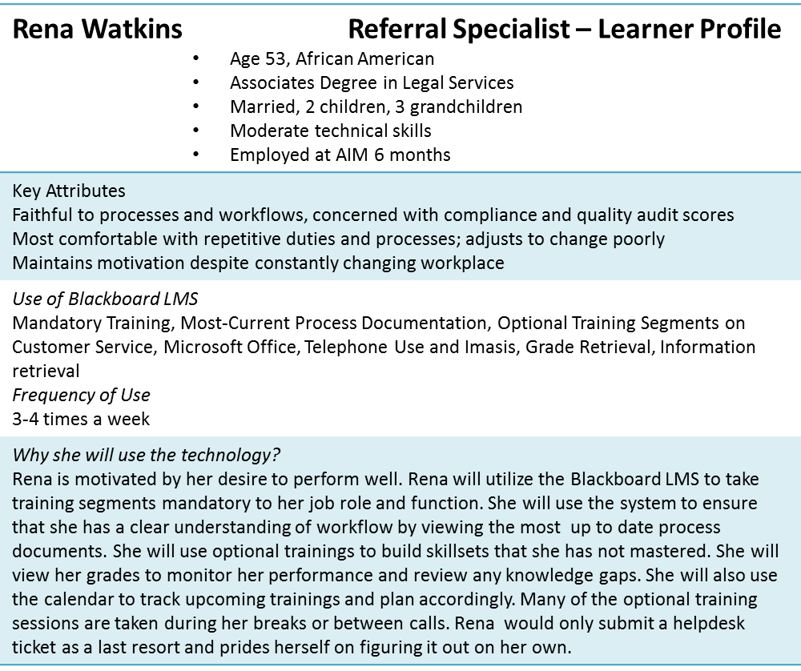
Technology Skill Level
This area is important to distinguish amongst user persona because it effects how the users interact with the system and there comfort level with exploration.



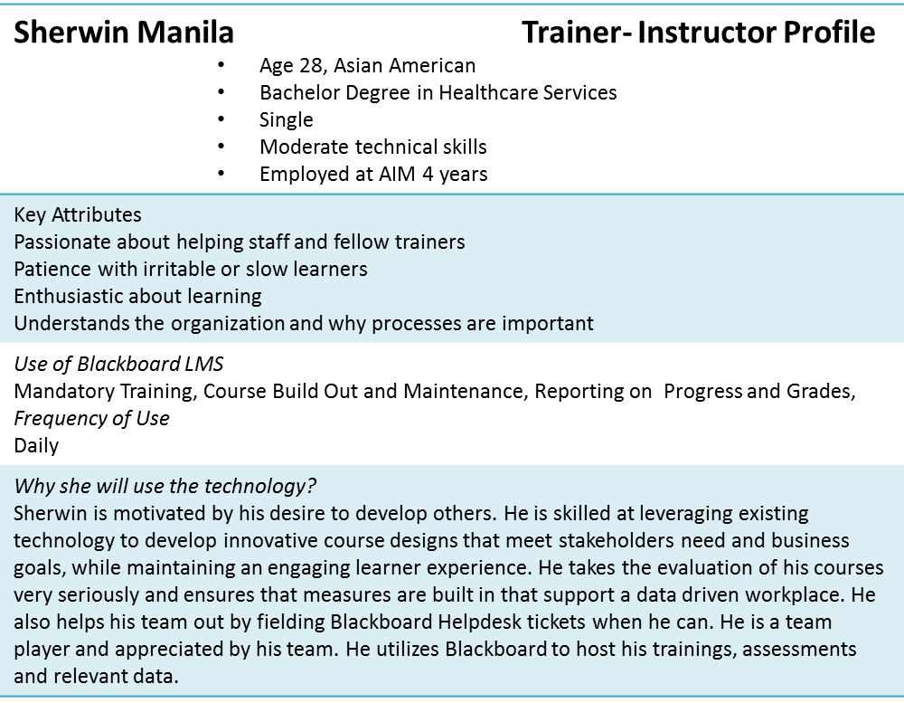
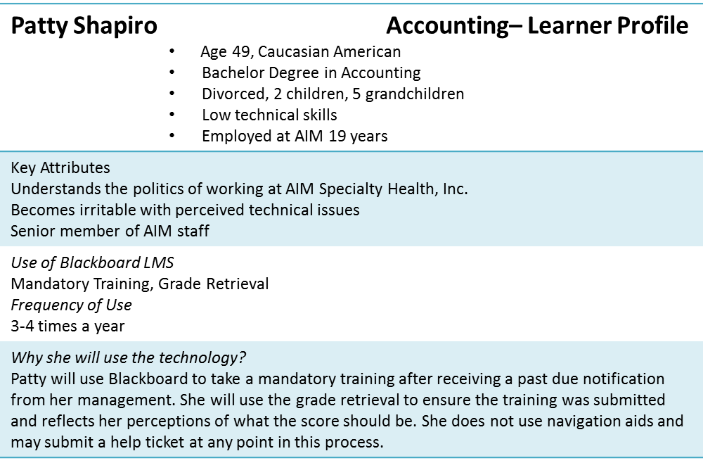
User Scenarios
The different personas will navigate through Blackboard for grades regarding a recent compliance training. In the case of users with a learning profile they will be looking for their personal grade, and the user with the instructor profile will be looking for all grades associated with the assessment.
Rena Watkins
- Enter into Blackboard through by clicking AIM Connect, an icon located on her desk top: 
- She is taken to the login page and selects, “Login”: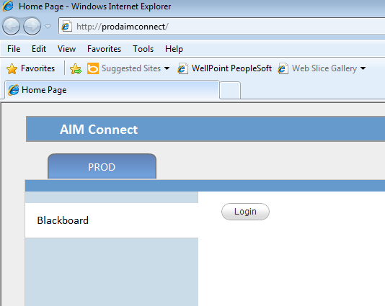
- Under the “My AIM Homepage”, she selects the Compliance Training Course: 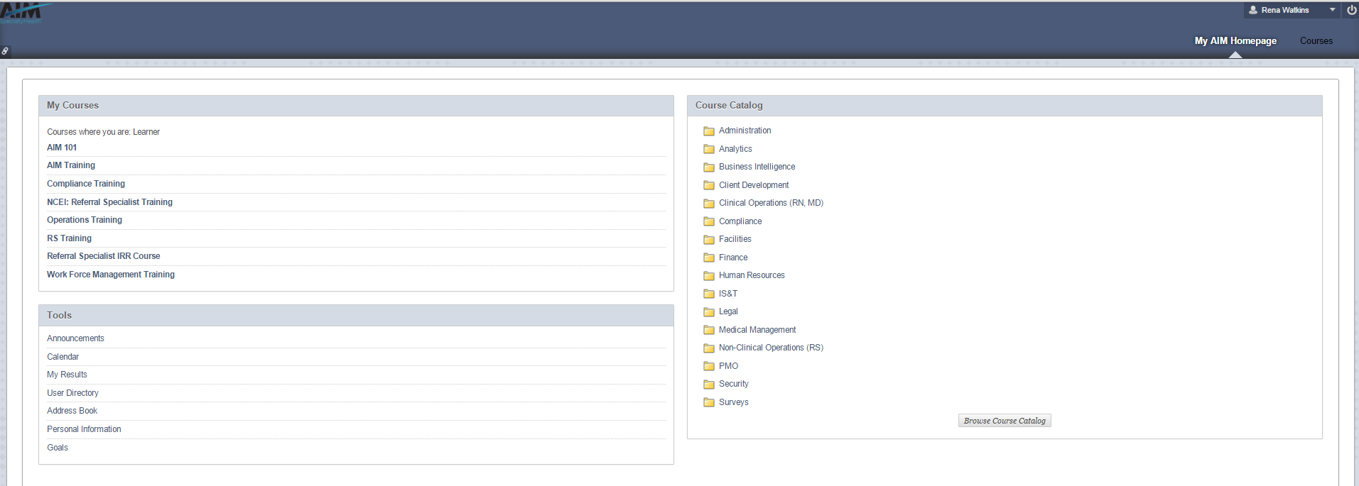
- At this point, she is interrupted by a call that lasts 5 minutes.
- The system does not automatically log her out, so she returns to same page.
- Once inside the course, she will recognize the table of contents on the right hand side and click on “My Grades”: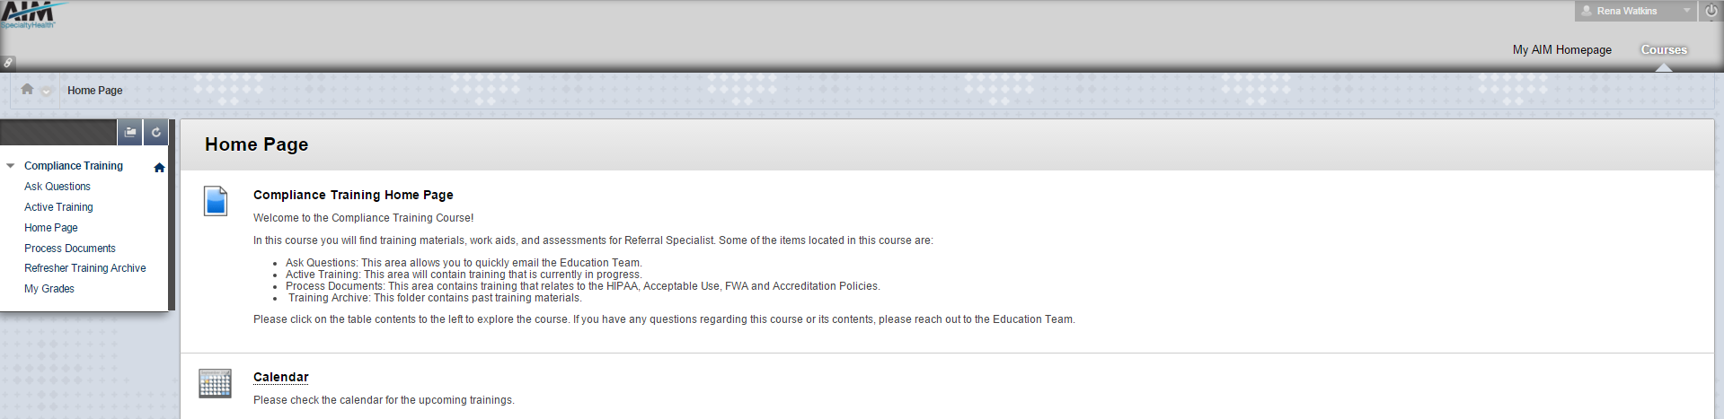
- Inside the results area, she will see her grade: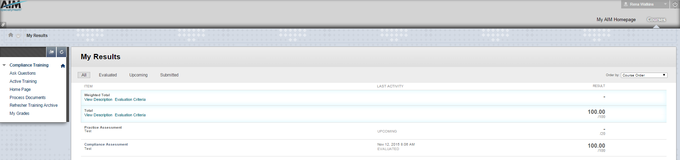
Patty Shapiro
- Patty will access Blackboard via AIM Connect:
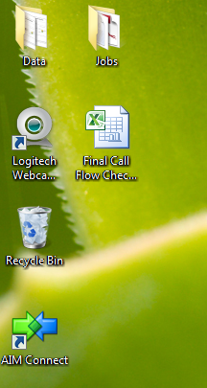
- She is taken to the login page and selects, “Login”:
- Under the “My AIM Homepage”, she selects the Compliance Training Course:
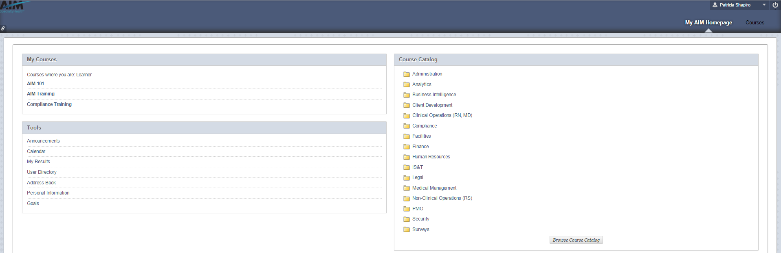
- Once inside the course, she reads the Homepage and clicks, “My Grades”:
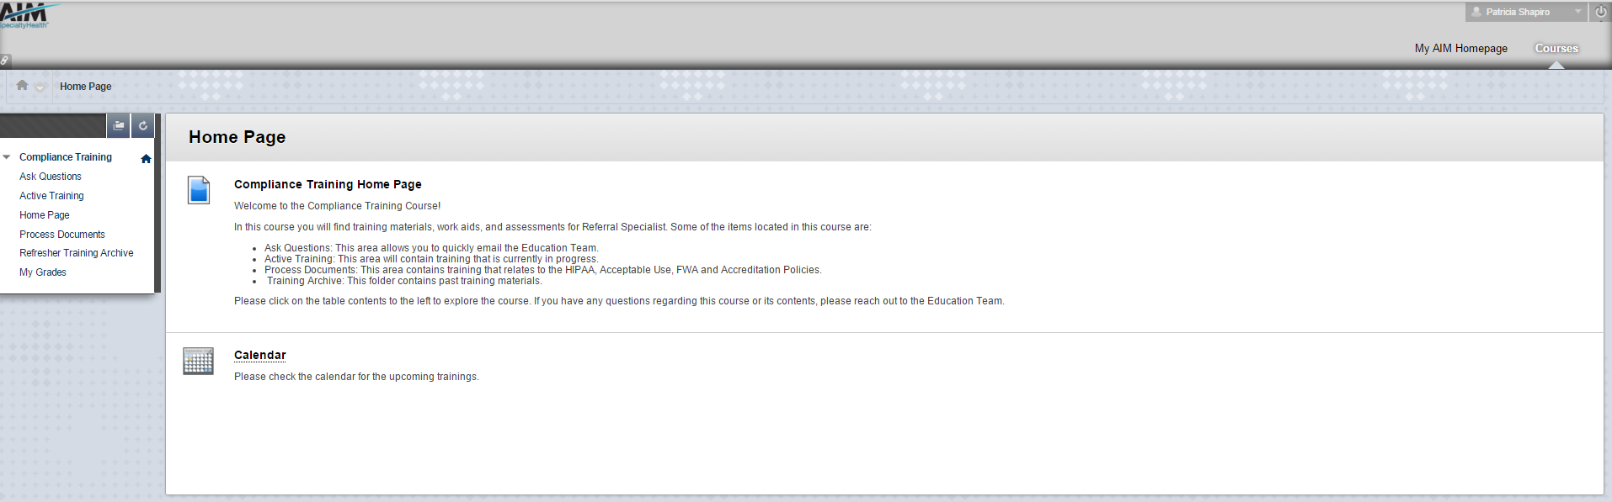
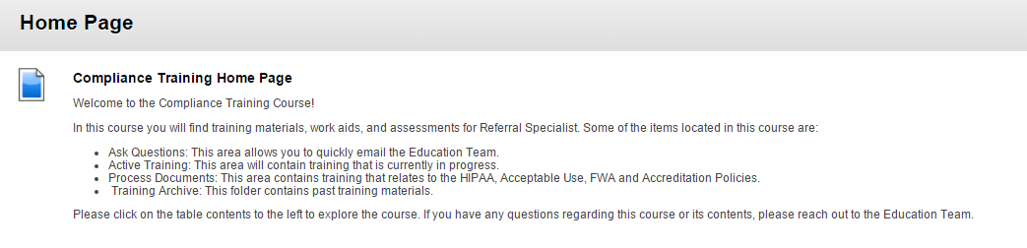
- Once inside the results area, she realizes she did not hit submit on the attestation:
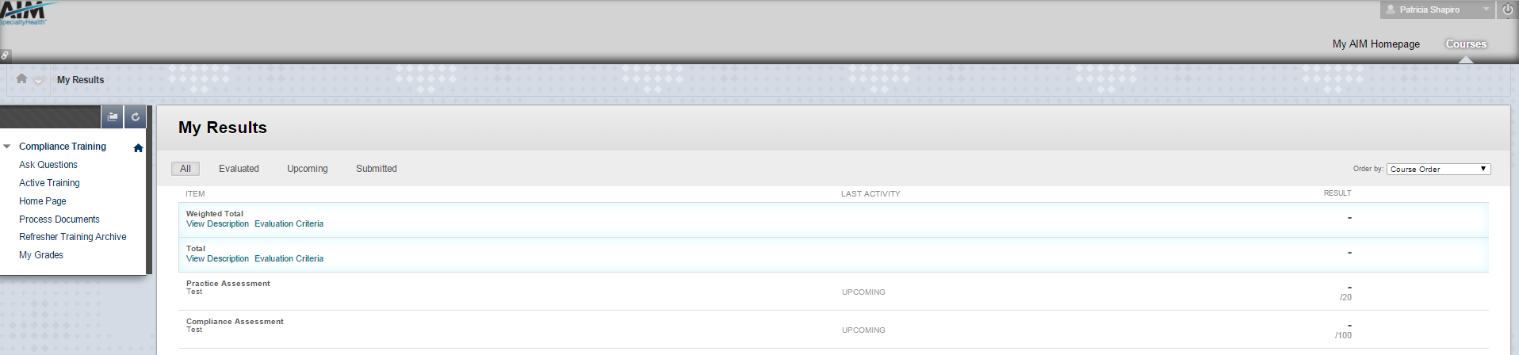
- First she sends the course instructor an email:
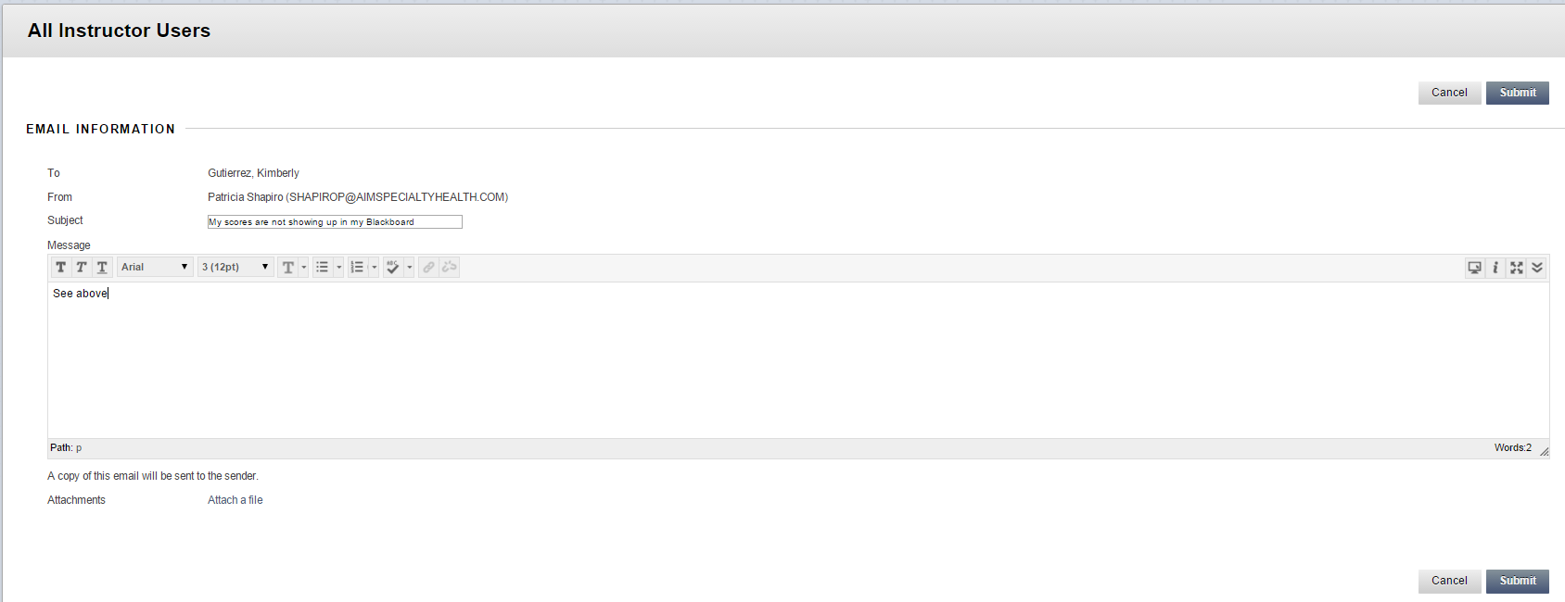
- The instructor sees that Patty did not hit submit, and the instructor manually submits the assessment. She then calls Patty and has her hit refresh:
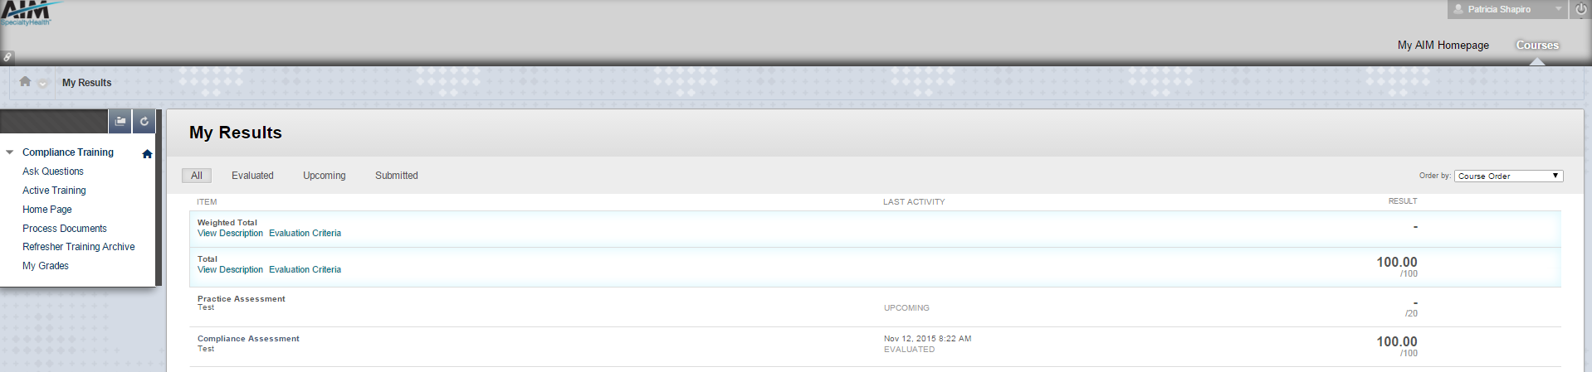
- After she sees her grade, she asks about the upcoming training. She is informed it is an optional training. Patty hangs up the phone and goes back to her Dunkin’ Donuts Coffee.
Sherwin Manila
Sherwin has an instructor profile and will be navigating to the site through an external website, as single sign on is linked to learner profiles.
- Sherwin will login to the external website:
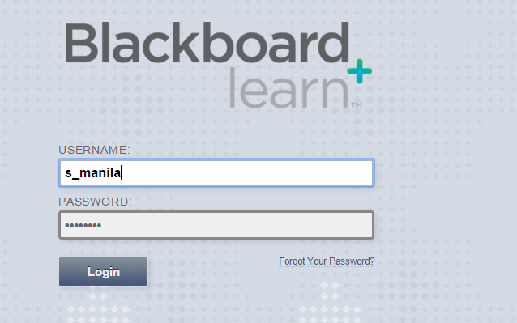
- After he has logged in, he will navigate to the Compliance Training Course:
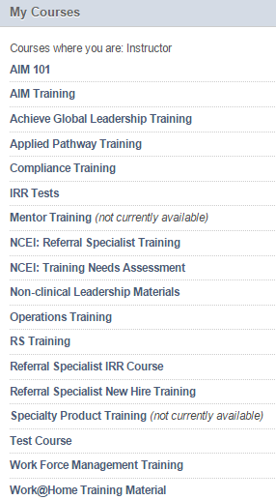
- Once inside the course, he will going into the Results Center in the Control Panel and select full results center:
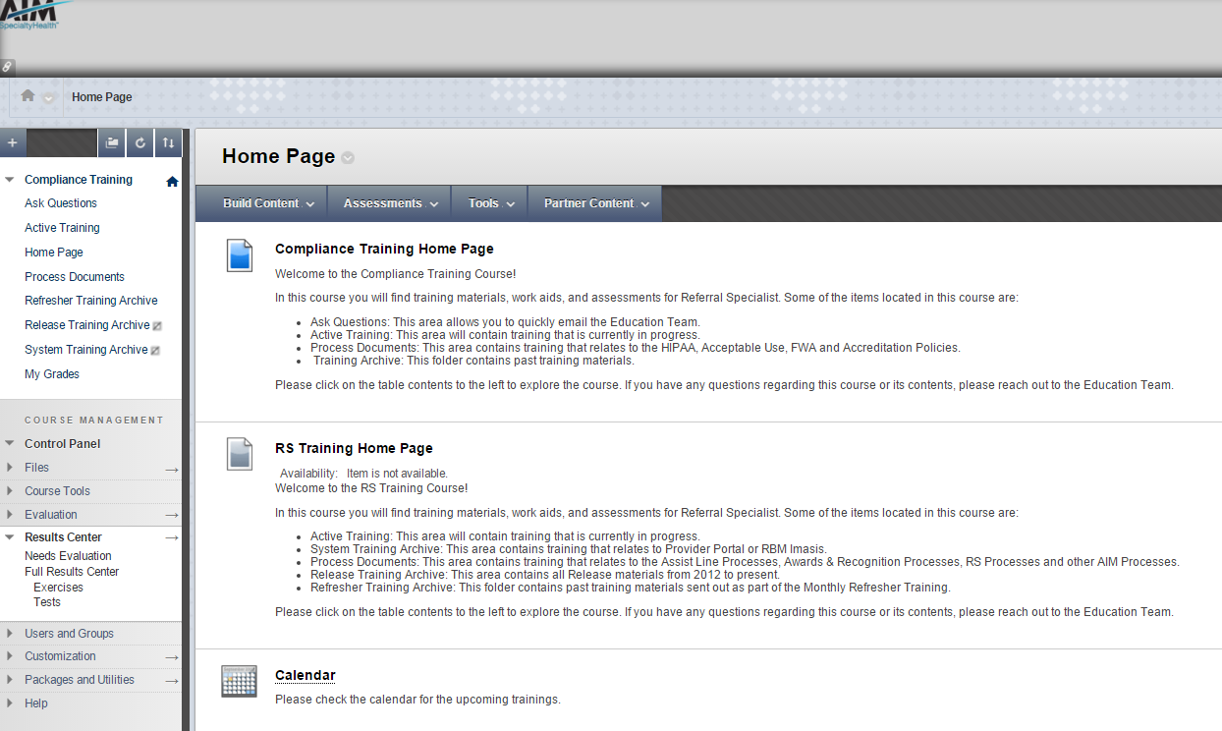
- From results Center, he will select, “Work Offline”:
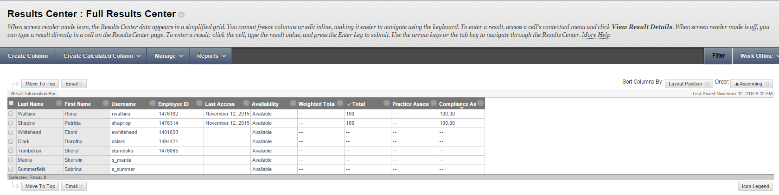
- The he will select, “Download”: 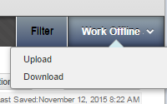
- He wil select, “Selected Column” and click on “Compliance Assessment”: 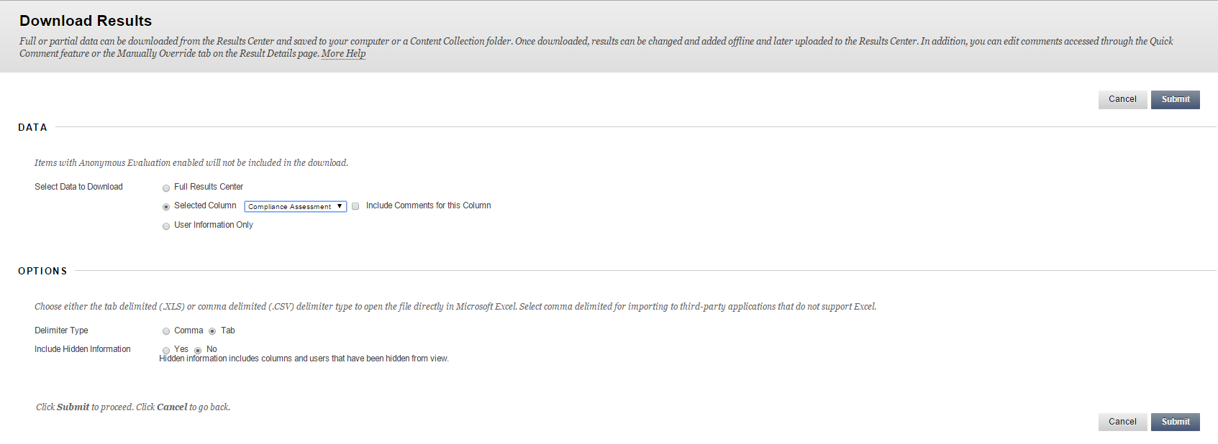
- He will hit “Submit”.
- He wil click Download:
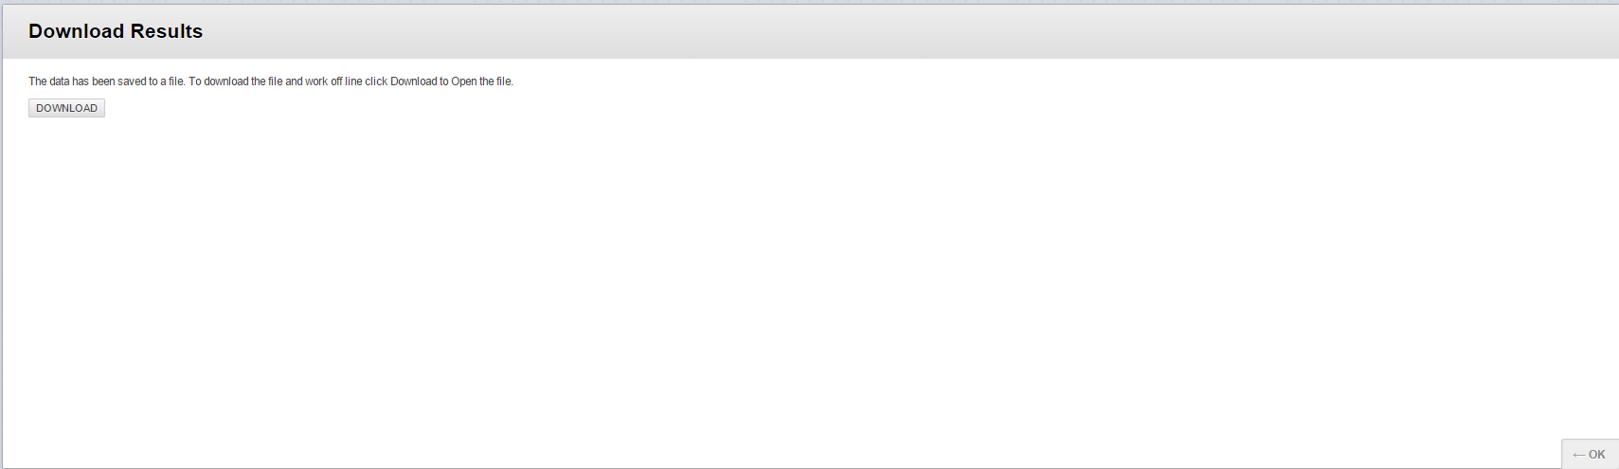
- The grades have been downloaded to his computer; he can open the document by double-clicking the document:
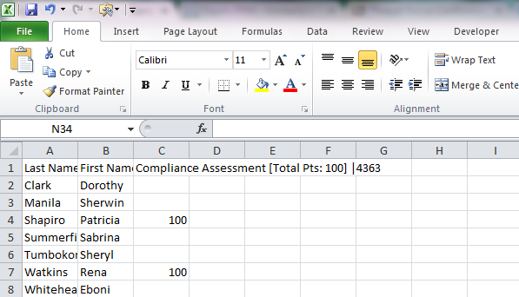
Summary
The user personas will be helpful in identifying how different users will utilize the system. Two issues that were bought to attention by these personas are potential interrupted use for call center staff, and additional help needed by novice users. As a large percentage of the system users will only be using the system 3-4 times a year, the system may still cause users to submit help desk tickets or require technical support for use. Also, important to note is that the system needs to support interrupted use. Taking these two issues into account in future redesigns will improve the user experience.

