Kim Gutierrez

Initial Protype
A Review of the Blackboard LMS

Emerging Themes from Focus Group and Expert Review
Based off of the analysis of data gathered through the Expert Review and Focus Group, these themes were identified:
- Blackboard should provide learners with a quick and easy way to navigate to needed materials.
  - Too much time is spent navigating to materials.
- Course content should be apparent in titles.
  - Time is spent exploring a course that does not have the needed materials.
  - Course with many learning modules are overwhelming
- Learner preference for many courses with fewer learning modules.
- Interface should be consistent throughout Blackboard.

Goals for Design Based On User Concerns
Based on the data collected from the focus group, the learner experience would be improved if the minor changes to the system interface were made to provide easier navigation, and less extraneous cognitive load associated with use. In an effort to improve the learning experience, the following improvements were taken into account:
- Search Box Availability
- Course Menu Consistency
- Simplify Design and Eliminate Waste
- Help and Documentation
Limitations
Blackboard does not support a search function. While this functionality was added to the prototype, it will not be available for use. This is a system limitation that cannot be altered by my design.
Course Design Selection
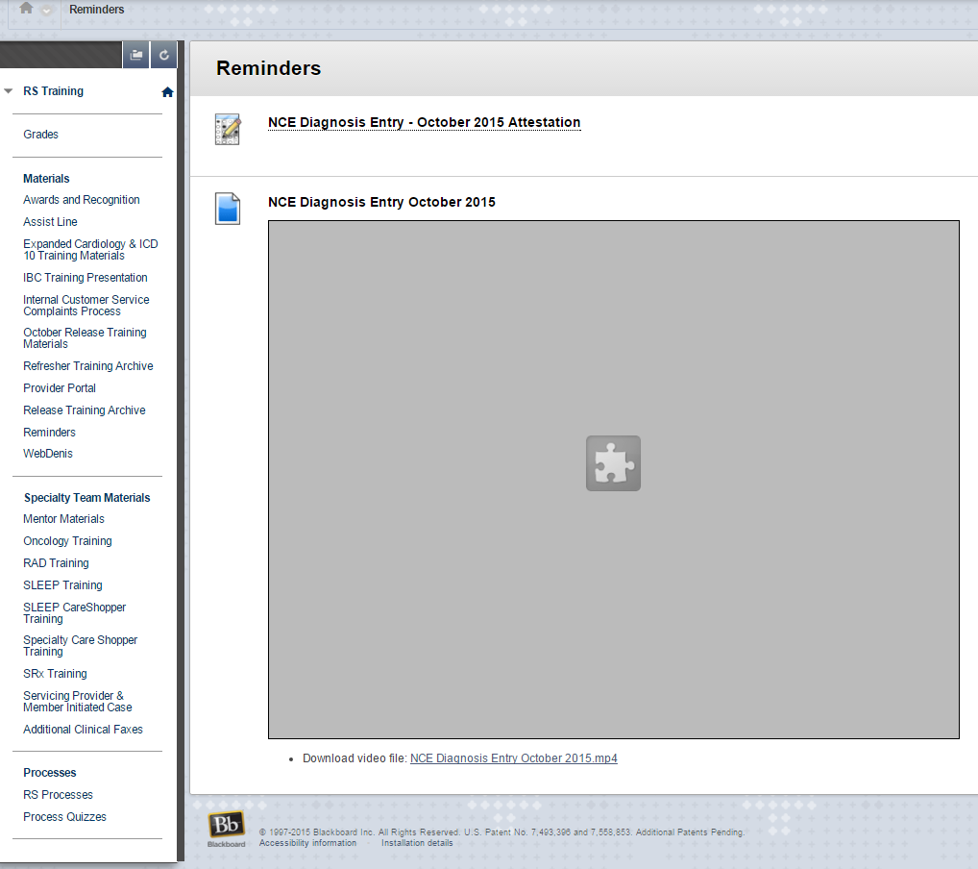(Before Redesign)
The RS Training Course was selected for redesign because it is one of the most heavily trafficked by AIM’s operational staff. It is also the course that requires the most user support based off of BMC Remedy Tickets. The first step of the redesign was to weed out unnecessary information from the course. This involved breaking the course into different working components: RS Training, Mentor Training, and Specialty Product Training. This supports a minimalist design within each course and will limit the time spent navigating inside the individual courses and the extraneous load associated with the navigation.

RS Training Couse Home Page
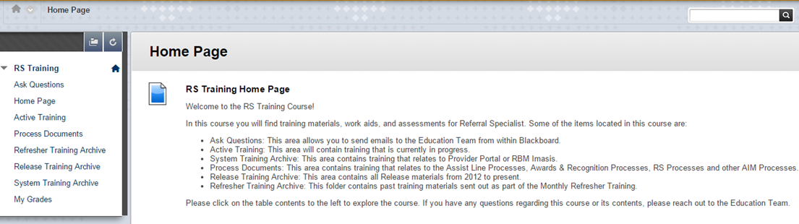
The homepage was redesigned for a minimalist and more aesthetic user experience. The renaming of content areas is a closer match between the system and the real world. These aspects of the redesign reduces extraneous cognitive load. This addresses users desire to have more courses with fewer learning modules. A search box is located on the homepage that allows users to search all courses that are available to them for needed items. The addition of a search box addresses user’s concerns with navigation time. A search function will also increase the efficiency of use, as it will allow users to locate the items they are looking for faster. The search box is something that users are already familiar with, so the training associated with this addition would be minimal. The “Ask Questions” selection was implemented to limit the Split Attention Effect associated with going to outlook to email the education team for support needed in the course. This addition also increases the help and documentation in the course. The homepage also contains a table of contents that makes users aware of the materials located in each content area. This is a form of pretraining that also serves as error prevention associated with users going into the wrong course or area. The redesign will improve the user experience in the course, as it will limit some of the extraneous load associated with navigating and processing unneeded information.
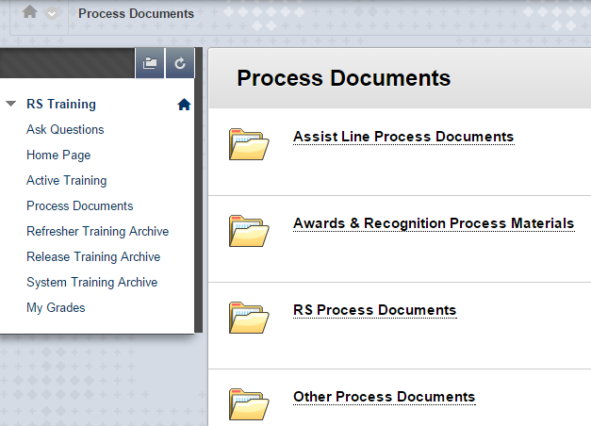
Inside the course, a minimalist design was followed by utilizing folders with titles easily recognized by users. This design limits the excess cognitive load associated with navigating the course for needed material. This design will limit the time associated with utilizing Blackboard, which will benefit the user and management.
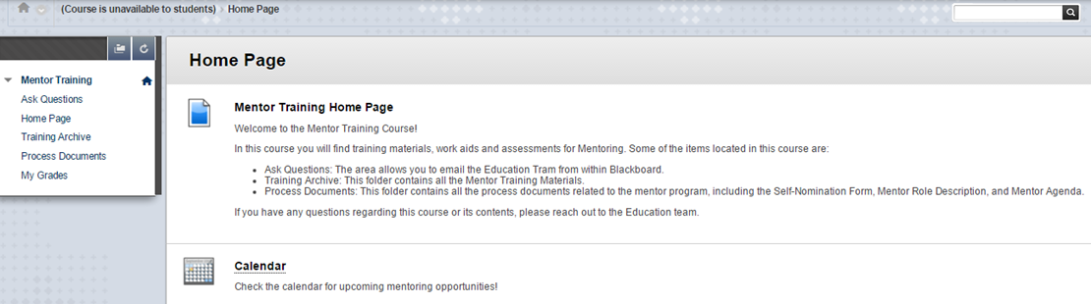
A consistent design from course to course will limit the extraneous load associated with adjusting to a new format. This design support’s users desire to have more consistent courses in Blackboard. The table of contents will be present in every course, so that the user recognizes needed content, versus relying on memory to navigate. A training calendar has been added to the course to limit Split Attention Effect associated with checking the Training Calendar hosted on the AIM Intranet.
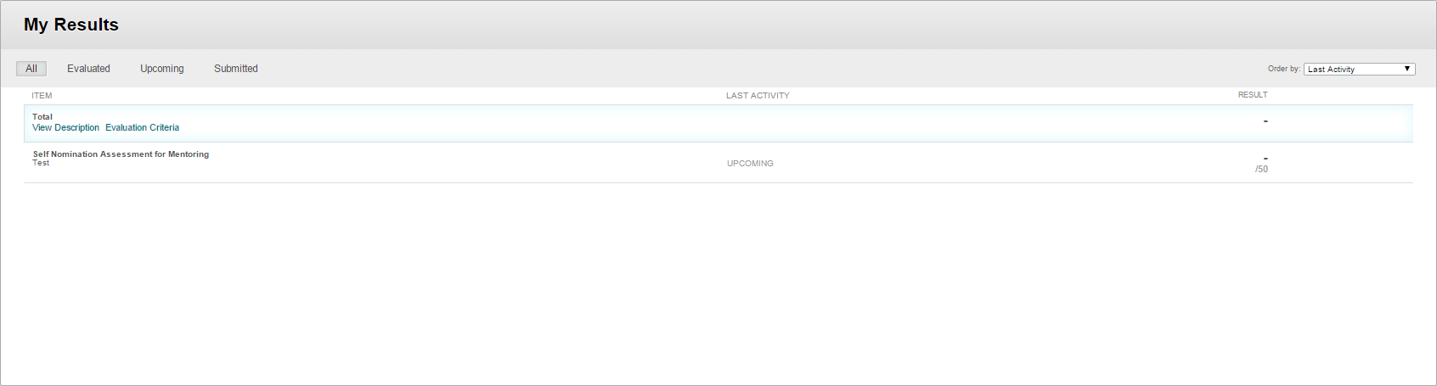
The gradebooks in the new courses are limited to assessments delivered in the last 12 months with older assessments appearing at the bottom of this view. This will limit the number of assessments in the course and allow users to more easily locate results. The minimal design will limit the extraneous cognitive load associated navigating this area.
Summary
Overall, the focus of this redesign was to limit the extraneous cognitive load associated with unnecessary navigation and the processing of unnecessary information. Nielsen’s 10 Heuristics were considered when planning the redesign along with Cognitive Load Theory. Over time, the redesign will increase efficiency of use and user experience in the Blackboard system.

