Kim Gutierrez

Program Evaluation
An Assessment Plan for the Mentor Program at AIM Specialty Health

Contents
Executive Summary 2
Background 2
Program Description 2
Program Size 3
Program Activities 3
Evaluation Need 5
Evaluation Purpose 5
Mentor Program Logic Model 6
Stakeholder List 7
Stakeholder Prioritization 7
Evaluation Design 9
Consolidated Evaluation Questions 10
Evaluation Plan Matrices 10
List of Evaluation Measures 11
Mentor Program Evaluation Timeline 12
Estimated Budget 13
Appendices 14
A. Evaluation Measures 14
A1. Mentor Program Evaluation for New Hires 14
A.2 Mentor Program Evaluation for Mentors 18
A3. Auditing Rubric 21
A4. Focus Group Questions 22
A5. Survey Notification Email 22
B. Evaluator Credentials 23
B1. Research Training 23
B2. Resume 24

Executive Summary
Since January of 2041, AIM Specialty Health has hired 288 new associates at the Referral Specialty job role; this is 28% of the overall workforce of the organization. New associates coming into the workforce impacts call center morale and the numbers presented to clients. In order to take advantage of this growth and ensure that he best possible candidates are being put on the floor, it is important that all programs associated with new hire development be closely evaluated. This evaluation plan was designed to evaluate the impact of the Referral Specialist Mentor Program. If an effort to evaluate the effectiveness of the Mentor Program in Preparing New Hire staff for success in the workplace, we will be breaking down the evaluation into two segments: Staff Reactions and Performance Impacts. This evaluation will address the needs of all stakeholders, by analyzing a combination of data, including survey data, and audit scores to provide management with insight into the effect the program is having on new hires and ultimately the call center as a whole.

Background

AIM Specialty Health (AIM) is a national leader in specialty benefits management. Through innovative approaches, AIM promotes the appropriate safe and cost effective use of clinical services. These services include diagnostic imaging, cardiology, oncology, specialty drugs, and sleep therapy. There are three operations centers, or call centers, under the AIM umbrella. These are located in Deerfield, Illinois, Westchester, Illinois, and Glendale, California. Callers who contact any of the AIM call centers experience up to three levels of service, depending on the nature of the call. Level 1 is the entry point for all callers and is not staffed by medical professionals. Level 1 of the call center is referred to as non-clinical. Levels 2 and 3 are jointly referred to as clinical as medical professionals staff them. Registered nurses staff level 2, and medical doctors staff Level 3. As the individual situations and the requirements for handling the calls becomes more complex, the caller is moved from Level 1 through Levels 2 and 3. The entire staff for all three levels is approximately 650 people, with 300 Level 1 employees.

Program Description

The program to be evaluated will be the mentor program for newly hired employees. Ownership of the program, which began in March 2013 under the Operations department, has been passed to the Learning and Development Department (L&D) due to the dissatisfaction of senior management with the productivity of new hires released from this program over the last 12 months. This evaluation will focus on the mentor program with current changes made by L&D staff. The goal of the mentor program is to aid new hires in acclimating to the new workplace while ensuring that the productivity and quality of the new hires quickly progresses to the level of seasoned employees.

Program Size

Currently the program involves 3 L&D staff members and 32 Operational Staff members across all 3 sites. The 32 Operational Staff members serve in the mentor roles. Mentors are selected through a self-nomination process with final adoption depending on auditing scores and manager approval. Due to recent high turnover rates, the number of new hires involved in the mentor program can vary between 12 and 24 at any given time.

Program Activities

The program is a 1 to 1 program with new hires being introduced to their mentors on the 2nd day of classroom training at a scheduled meet and greet. After introductions on day 2, the new hire will spend 2 hours a day shadowing their mentor over the remainder of classroom training (2 weeks total). After classroom training has ended, the new hire will work with their mentor everyday on different competencies related to the job and the new hire’s progress. This training will be done in the field through a combination of mock calls, feedback and live calls. The mentor will evaluate the new hire’s progress every day using a rubric consistent with the rubric used by the Auditing Department when the new hire is release from the mentor program. The same rubric is used during classroom training, but with mock calls. Release from the mentor program is dependent on daily scores and mentor recommendations.

Evaluation Need

The Mentor Program Evaluation Plan will determine the impact of changes made by the L&D department after taking ownership of the program. Senior Management is very concerned with the productivity rates, poor morale and high turnover rates of new hires. This data for the Operation-owned program and new L&D owned program will need to be available with trends and conclusion clearly visible. This program evaluation will be deigned to be deployed 3-6 months after the changes have been implemented. This would be a formative evaluation that would be used to make needed adjustments and inform the construction of the summative evaluation at 12-18 months. Some of items the program would be evaluating are:
- New Hire job satisfaction trends and correlations between the two programs. This would be determined by a survey that evaluates different areas.
- New Hire Average Talk Time and Quality scores correlations and trends between the two programs.
- Changes that have had negative impacts have been addressed.
- Additional areas of improvement have been identified, evaluated and implemented.

Evaluation Purpose

The purpose of this evaluation is to demonstrate the effectiveness of the AIM Specialty Health Mentor Program in preparing New Hire Staff members for success in the workplace. The results of the evaluation will be used to enhance the design, content and activities associated with this program.

Mentor Program Logic Model
Resources | Activities | Outputs | Outcomes | Impacts
- 3 Mentor Program Coordinators (L&D Staff from all 3 sites)  - Mentors (Operations Staff: 12 from each site available full-time)  - New Hires (Operations Staff Time: No more than 12 per class)  - Planning/Design Time (L&D Staff Time)  - Training Time (Operation Staff Time)  - Knowledge Base (Mentoring best practices, training knowledge, survey results and other relevant information)  - Training and Support Materials  - Classroom/Meeting Space  - Learning Management System (Blackboard)  - Other Available Technology (computers, communications infrastructure, printers, etc.)  - Support of Stakeholders (Senior Management)  - Additional Funds (for Mentor/New Hire Meet and Greet Snacks, and Graduation Lunch) | Supporting  - L&D Staff Training  - Mentor Training  - Mentor-New Hire Observation Sessions  - Recruitment of New Mentors through lunch and Learns  - Screening applicants  - Matching Mentor Pairs  - Coordinating Program meetings and structured activates  Direct Services  - New Hire-Mentor Meet and Greet Workshop  - 2 week-long ,structured job shadowing for New Hires  - 2 week long structured field training for New Hire  - Daily evaluation of progress of New Hire  - Graduation Session  Evaluation  - New Hire evaluation of Mentor and Mentor Program  - Mentor Evaluation of Mentor Program | - Implementation of training program for L&D staff  - Implementation of training program for mentors  - Quality assurance and consistency in program implementation  - Quality assurance and consistently in mentor selection  - Program introduced to new hires through socialization  - New Hires are introduced to structure of the Mentor Program from Program start  - New Hire develops job related skills  - New Hire adapts to workplace culture  - New Hire is aware of his/her progress and expectations  - Data from the perspective of New hire and mentor  The Numbers  - # of staff trained  - # of mentors trained  - # of observations  - # of matches made  - # of Meet and Greets  - # of Graduates | - Understanding and standardization of program coordination for mentor program at all 3 sites  - Standardization of expectations and mentor skills at all 3 sites  - Improvements to quality of mentor selected to the program  - Mentors and new hires develop social relationship  - Increase in social support from mentors  - Increase in the quality of the mentor-new hire relationship Increase in New Hire self-esteem/confidence  - New hire is able to develop needed skills earlier in the program  - Increase in the quality of new hires leaving the mentor program | - Increase in L&D, and Operations staff satisfaction with the program  - Increase in the efficiency of program coordination  - Decrease in average time to competency for New Hires  - Increase in job satisfaction for new hire staff  - Decrease in turnover rate for all staff  - Increase of performance of all staff  - Increase in the job satisfaction of all staff

Stakeholder List
STAKEHOLDER | TO MAKE POLICY | TO MAKE OPERATIONAL DECISIONS | TO PROVIDE INPUT | TO REACT | FOR INTEREST ONLY
Senior Management | X | X
L&D Management | X | X | X
Operations Management |  | X | X
Program Coordinators |  | X | X
Other L&D Staff |  | X | X
Mentors |  |  | X | X
New Hire Staff |  |  | X | X
Other Operations Staff |  |  |  | X
Other AIM Staff |  |  |  |  | X
Other Anthem Staff |  |  |  |  | X
AIM/Anthem Clients |  |  |  |  | X

Stakeholder Prioritization
- L&D Management
- Senior Management
- Program Coordinators
- Other L&D Staff
- Operations Management
- Mentors
- New Hires
- Other Operations Staff
- Other AIM Staff
- Other Anthem Staff
- AIM/Anthem Clients
The Stakeholders are prioritized by ranking them from most important to least. L&D and Senior Management will have the highest priority as they will make decisions concerning the future of the program based off the evaluation results. Ultimately, these two groups will decide if they program has a future. The Program Coordinator and L&D Staff will have a moderately high priority as they will be making changes to the program based off the information received. These two groups will be rewarded for the success of this program. Operations Management will have a moderate priority. While this group is not directly involved with the program, the results of the evaluation may affect the supply of staff or the quality of staff they provide for this project. Mentors will also be a moderate priority in this project as they will be involved with the program on daily basis during their implementation and the success of the program depends on their implementation. Their feedback will determine any program changes. Mentors will be responsible for the day-to-day program implementation. The mentors will be evaluated on the success of the program and poor mentoring will lead to their removal from the role. The results of this evaluation may affect their decision to participate in the program. New Hire staff will have a moderate priority, while they are involved with the program on a daily basis for their first month of employment and their job performance depends on the success of the program, this group will not make any decision based on the evaluation, though they may be asked for additional input. Other Operations staff will be aware of the program, but will not participate in any other aspect of the program. This group will benefit from the long-term impacts of the program. Other AIM Staff, other Anthem staff, and AIM/Anthem Clients are low priority. These groups will not participate in the program and may not know the program exists but, they will benefit indirectly from the long-term success of the program.

Evaluation Design
Emphasis | Stakeholders | Questions | Uses
Relationship Building | New Hires | What do I need to be successful? | Mentee/Mentor Pairing
Relationship Building | Mentors | How can I build a relationship with my mentee? | Mentee/Mentor Pairing
Relationship Building | Program Coordinators | How can we facilitate relationship building? | Identify training/support needs, Program Improvements
Relationship Building | Other L&D Staff | What additional support does relationship building require? | Technology integration considerations, Identify training/support needs
Relationship Building | L&D Management | How can I measure the impact of relationship building?  How many of my staff hours are consumed by this?  Is there a better use of resources? | Resource allocation, Identify training/support needs
Relationship Building | Operations Management | How does relationship building enhance my staff?  How many of my staff hours are consumed by this? | Resource allocation
Relationship Building | Senior Management | What is the cost-benefits analysis of relationship building?  How does relationship building impact culture? | Program Review, Annual Reports, Marketing Materials, Meeting Topics, Resource allocation
Relationship Building | Other Operations Staff | Are the new hires better co-workers? | Workplace Onboarding, Employee satisfaction
Relationship Building | Other AIM Staff | Will staff be better prepared to handle calls? | Annual reports
Relationship Building | Other Anthem Staff | How can we sale this to clients? | Annual Reports, Marketing
Relationship Building | AIM/Anthem Clients | What are the numbers? | Future Investment
Performance | New Hires | How do I meet performance expectations? | Bonus allocation
Performance | Mentors | How can I prepare my new hire to meet performance expectations? | Program Improvements
Performance | Program Coordinators | How effective is the program?  What improvements need to be made? | Program Improvements Identify training/support needs
Performance | Other L&D Staff | What additional support/ improvements are needed? | Technology integration considerations, Identify training/support needs
Performance | L&D Management | How can I show program impact on performance?  How many of my staff hours are consumed by this?  Is there a better use of resources? | Resource allocation, Meeting Materials
Performance | Operations Management | How many of my staff hours are consumed by this?  Is there a better use of resources? | Resource allocation
Performance | Senior Management | How does this impact the numbers? | Program Review, Resource allocation, Annual Reports, Marketing Materials
Performance | Other Ops Staff | Will I be less overwhelmed by calls in queue? | Employee satisfaction
Performance | Other AIM Staff | Will staff be better prepared to handle calls? | Annual reports
Performance | Other Anthem Staff | How can we sale this to clients? | Annual reports, marketing
Performance | AIM/Anthem Clients | What are the numbers? | Future Investment

Consolidated Evaluation Questions
Evaluation Question | Rationale
How are mentors/ new hires reacting to the program? | Addresses questions from all stakeholder groups
How had the program impacted performance? | Addresses questions from all stakeholder groups

Evaluation Plan Matrices
Evaluation Question | How are mentors/ new hires reacting to the program?
Information Required | Mentor and New Hire Opinions about the program
Source | Mentors and new hires that have participated in the program
Method | Mentor Survey Evaluation of Program, New Hire Survey Evaluation of Program and Mentor; Mentor Interviews;
Sample | The Mentor Survey Evaluation would be for all mentors; New Hire Surveys will be for each new hire class; Mentor Interviews with all veteran mentors
Schedule | The Mentor Survey Evaluation will be delivered quarterly; New Hire Surveys will be delivered at the end of each new hire class; Mentor Interviews with all veteran mentors at 6 months
Information Collection Procedures | The Mentor and New Hire Surveys will be administered via Blackboard’s enterprise survey; all surveys will be anonymous, voluntary and reported in aggregate. Mentor Interviews will be conducted through one-on-one sessions with the program coordinator
Analysis Procedures | Results from surveys and interviews will be analyzed by reviewing for trends and analyzing for covariance.

Evaluation Question | How had the program impacted performance?
Information Required | Audit Records
Source | Departmental Records
Method | New Hire calls will be audited utilizing the RBM RS Audit Form
Sample | New Hires will have at least one call audited every day after their 3rd day of new hire class
Schedule | Audits Day 4 – Day 10 completed by new hire trainer with mock callers, Audits Day 15 –Day 20 completed by mentor with live callers, Audits Day 20+ completed by the auditing team with live callers
Information Collection Procedures | On days 4 through 20 the rubric will be filled out and housed in Blackboard, on Day 20+ rubric information will be housed in NICE call recoding software. All information is accessible through the individual platforms or a consolidated report can be pulled through the reporting department.
Analysis Procedures | Results will be analyzed by reviewing records for trends.

List of Evaluation Measures
Mentor Program Evaluation Survey for New Hires
Mentor Program Evaluation Survey for Mentors
Auditing Rubric
Focus Group Questions for Veteran Mentors

Mentor Program Evaluation Timeline

Task | Person(s)  Responsible | January 2015 | February 2015 | March 2015 | April 2015 | May 2015 | June 2015 | July 2015 | August 2015 | September 2015 | October 2015 | November 2015 | December 2015 | January 2016
Mentor Program Implementation | Program Coordinator, Mentors
Conduct Mentor Program Evaluation Survey for New Hires | Evaluator
Conduct Mentor Program Evaluation Survey for Mentors | Evaluator
Analyze Survey Data | Evaluator
Gather Audit Records | Evaluator, L&D Staff, Auditing Staff
Analyze Audit Records | Evaluator
Conduct Focus Group for Veteran Mentors | Evaluator, L&D Staff
Analyze Focus Group Data | Evaluator
Prepare Findings and Recommendations | Evaluator
Present Findings and Recommendations | Evaluator
Planned program changes | Program Coordinator, L&D Staff
Program Change Implementation | Program Coordinator, L&D Staff
Final Report Due | Evaluator
This signifies the end of this evaluation.

Estimated Budget

Associate Expense | Time (hours)
Hourly Direct Costs
Evaluator, 13 months @40 hrs./wk. | 2080
L&D Staff Support, 13 months @ 5 hrs./wk. | 260
L&D Management (meetings & support) | 52
Senior Management (meetings) | 26
Ops Management (meetings) | 13
Staff Participation (surveys & interviews)2hrsX36mentors* | 72
New Hire Participation (surveys) 15min.X250 new hires* | 62.5
Total Cost in Time | 2,565.5
Monetary Direct Costs
Participant Support Costs ( | In-Kind*
Communication Tools, Blackboard, Infrastructure, and Other Software | In-Kind**
Computers, Phones, Meeting Rooms, Office Facilities | In-Kind**
Office Supplies and Other Materials | In-Kind**
Total Cost in Money | In-Kind
*Costs have been provided for in the L&D Budget.
**Costs have been provided by the facility.

Appendices

Evaluation Measures

A1. Mentor Program Evaluation for New Hires
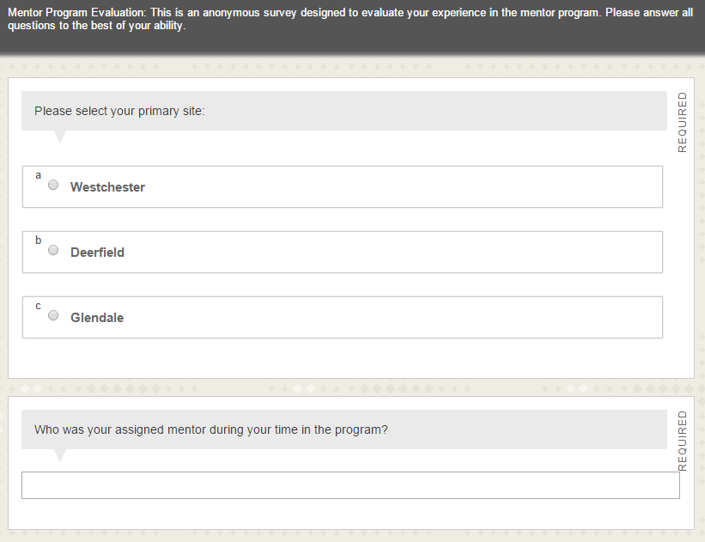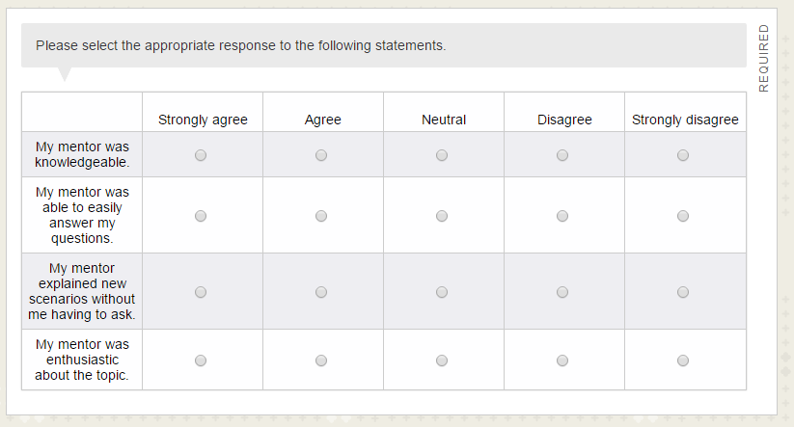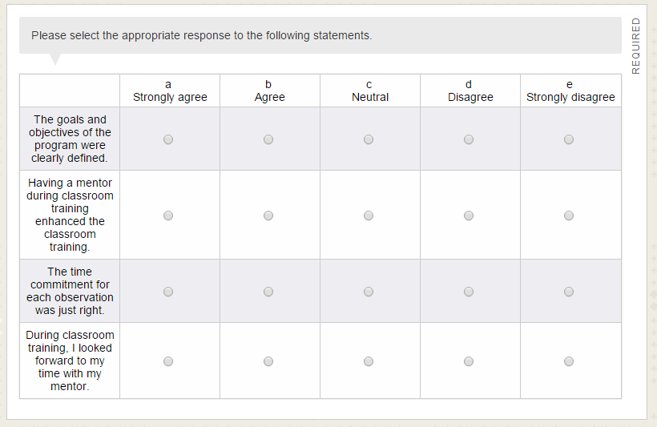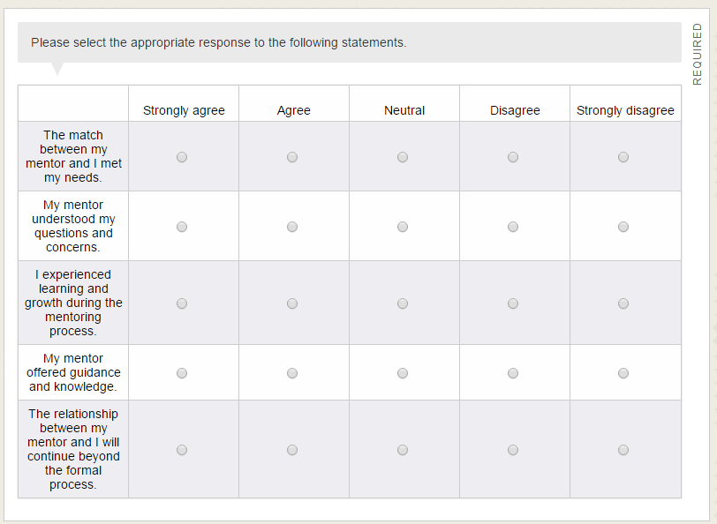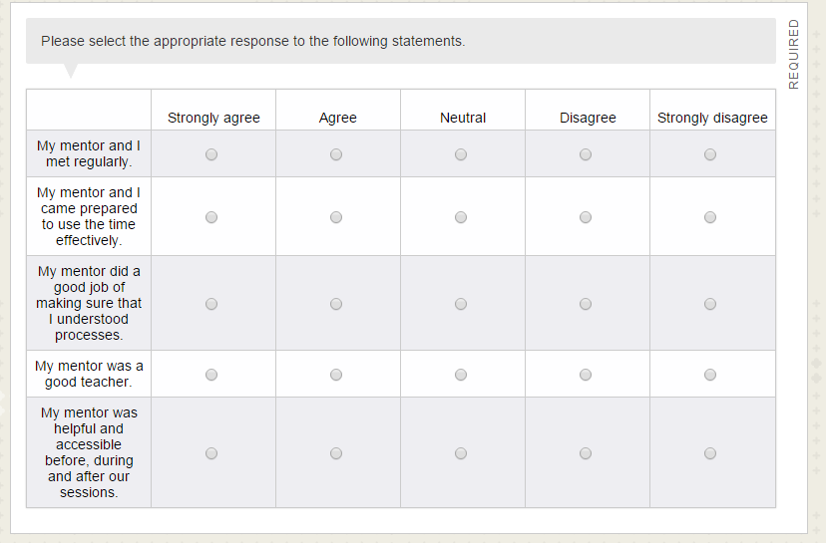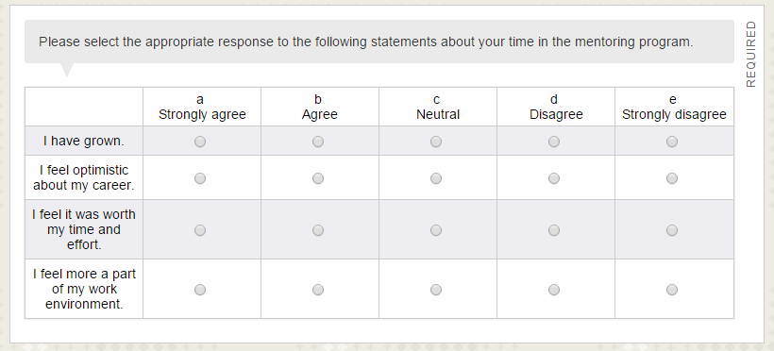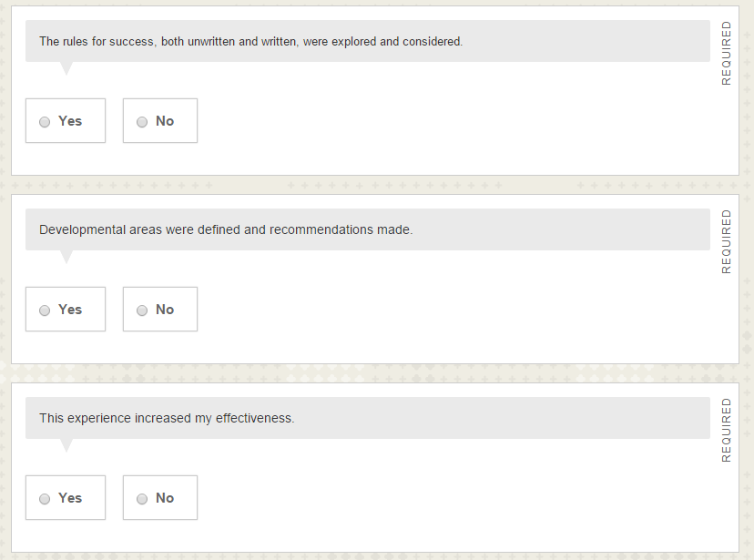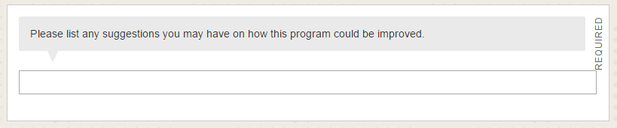

A.2 Mentor Program Evaluation for Mentors
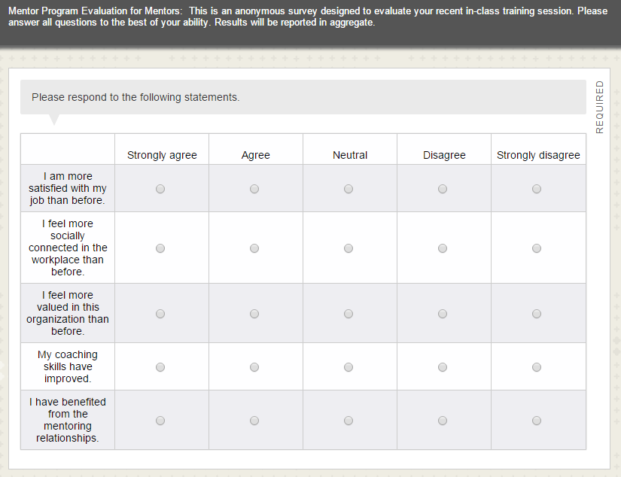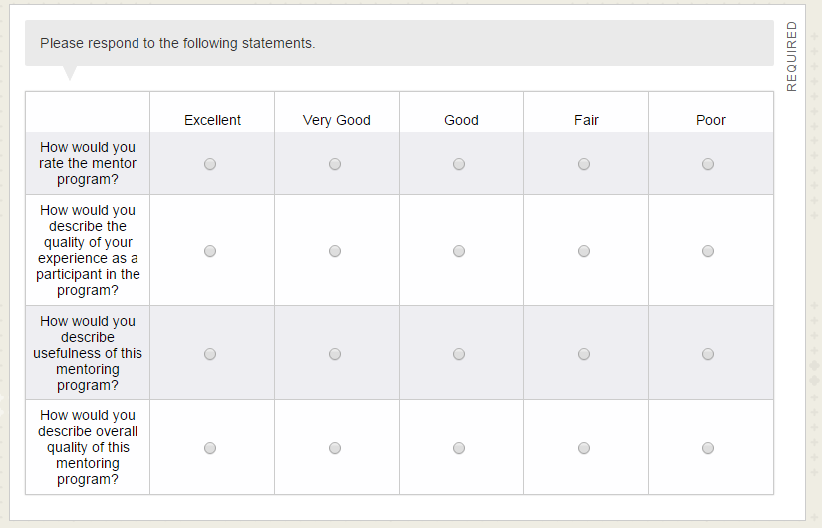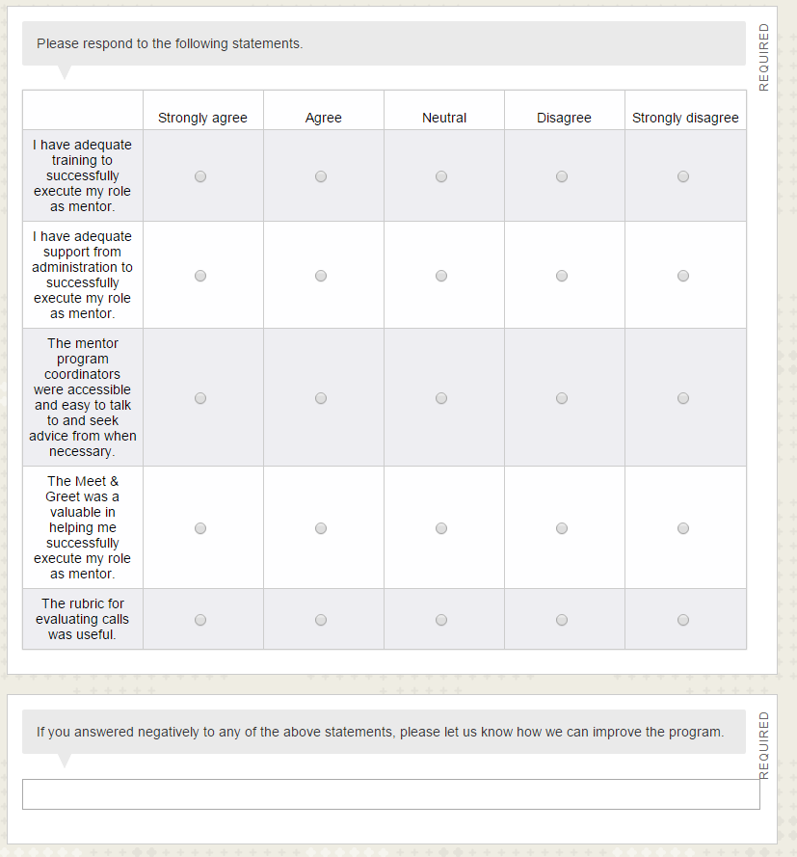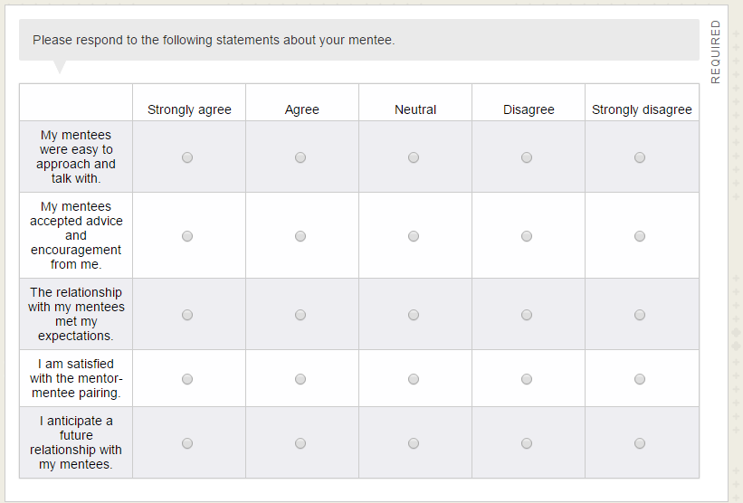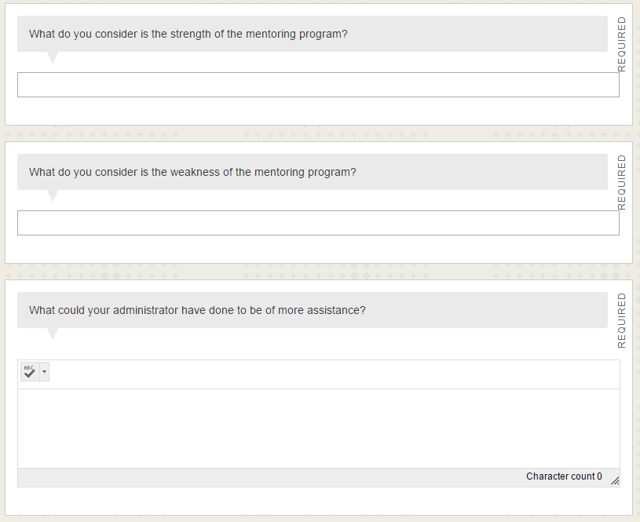

A3. Auditing Rubric
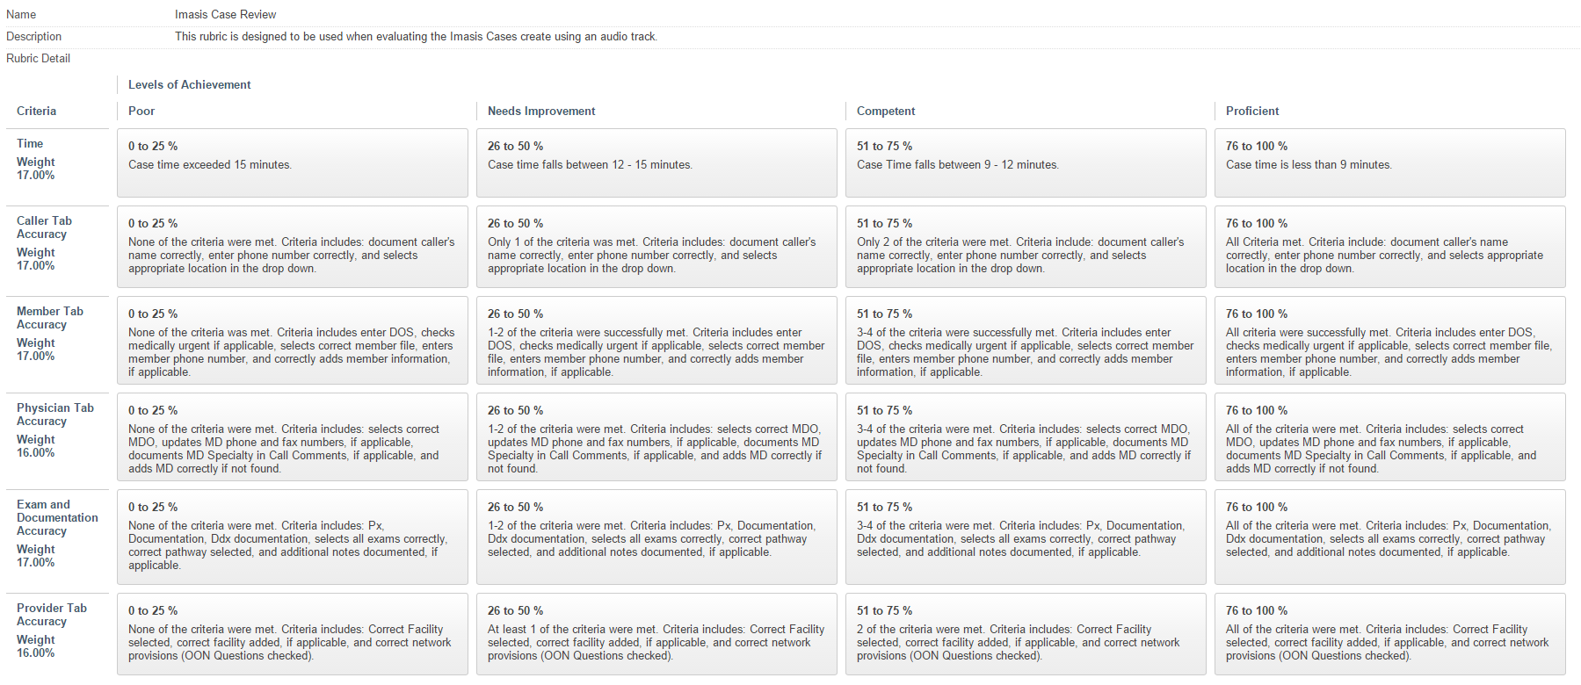

A4. Focus Group Questions
- What do you like about the current mentor program?
- What would you change about the current mentor program?
- What do you think about the change from manager nominated mentors to a self-nomination process?
- What do you think about moving from a two to one ration to a one to one?
- What do you think about the review process changes?
- How would you improve the program?

A5. Survey Notification Email
Subject: Please respond: Mentor Evaluation

Good Morning,

The Mentor Program is an essential part of an effective new hire onboarding experience. In line with our commitment to continuous improvement, we are looking to examine our current performance across a broad range of topics regarding the Mentor Program. The best way to do this is by asking you to participate in the Mentor Program Survey and to provide us with your opinion on your recent experience.

The survey is completed on-line, and should take around 5 minutes to complete. The survey is set out in a number of sections and every statement in each section should be responded to before moving to the next.

Please remember, there is NO right or wrong answer. It is your honest feedback we are seeking. Should you have any concerns or questions about this survey, please feel free to contact the Education Team at EducationTeam@aimspecialtyhealth.com.

This survey will be available for 1 week. By participating in this survey you will be making an important contribution helping AIM Specialty Health to improve and to better serve its employees.

Thank you,

The Education Team

Evaluator Credentials

B1. Research Training
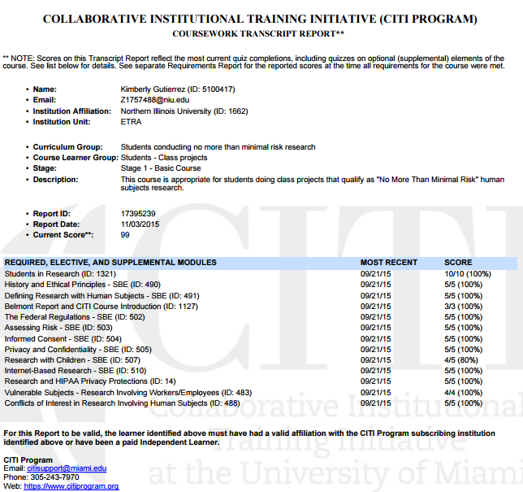

B2. Resume
